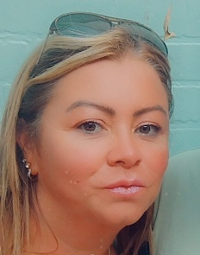
Hello!

Name: Nine Boyle
Area: Staffordshire
About me:

Hey !
I’m Nina I am one of the tutors at SEIN. I love to encourage and support students creatively with their views and ideas at the heart of each session.
I like to work in way that will build confidence in each student. Listening to what they want from our service.
I have worked in education for 20 years in primary and secondary schools, where I delivered child development and health and social.
I have 3 children and a dog, I love walking and visiting the sea side.
I’m looking forward to meeting you .

